User-Password database credential
# Source: AI Source: Provided by: [Data Path: Persons Table -> ID Column: 1, Name_En Column: Motasem Essam] -> From: [ChatGPT] on [1/18/2026]
The User/Password type of database credential is the most common and basic method for authenticating to a database. It uses a username to identify the user and a password to verify their identity.

👤 What It Is
# Source: AI Source: Provided by: [Data Path: Persons Table -> ID Column: 1, Name_En Column: Motasem Essam] -> From: [ChatGPT] on [1/18/2026]
- Username → identifies the database account
- Password → proves the user is allowed access
Example
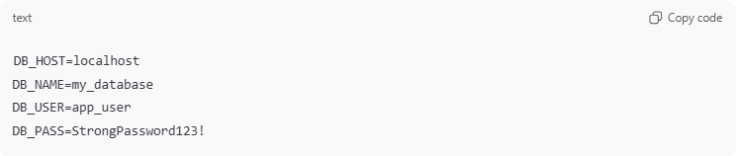
DB_HOST=localhost
DB_NAME=my_database
DB_USER=app_user
DB_PASS=StrongPassword123!

🛠️ How It Works
# Source: AI Source: Provided by: [Data Path: Persons Table -> ID Column: 1, Name_En Column: Motasem Essam] -> From: [ChatGPT] on [1/18/2026]
- Application or user tries to connect to the database
- Database server checks the username and password against stored credentials
- If they match, the connection is established
- Permissions associated with the user determine what operations are allowed

📍 Where It’s Used
# Source: AI Source: Provided by: [Data Path: Persons Table -> ID Column: 1, Name_En Column: Motasem Essam] -> From: [ChatGPT] on [1/18/2026]
- All types of databases: MySQL, PostgreSQL, Oracle, SQL Server, MongoDB
- Web applications connecting to backend databases
- Admin tools (phpMyAdmin, pgAdmin, etc.)
- Internal applications accessing databases

✅ Advantages
# Source: AI Source: Provided by: [Data Path: Persons Table -> ID Column: 1, Name_En Column: Motasem Essam] -> From: [ChatGPT] on [1/18/2026]
- Simple and widely supported
- Easy to implement in applications
- Fine-grained access control possible (roles/privileges)

⚠️ Disadvantages
# Source: AI Source: Provided by: [Data Path: Persons Table -> ID Column: 1, Name_En Column: Motasem Essam] -> From: [ChatGPT] on [1/18/2026]
- Passwords can be guessed, stolen, or leaked
- Hard-coded passwords in apps create security risks
- Users often share accounts, reducing accountability
- Requires secure storage and management

🔒 Best Practices
# Source: AI Source: Provided by: [Data Path: Persons Table -> ID Column: 1, Name_En Column: Motasem Essam] -> From: [ChatGPT] on [1/18/2026]
- Use strong, unique passwords
- Store passwords securely (environment variables or secrets managers)
- Avoid using the root/admin account for applications
- Rotate passwords regularly
- Enable encrypted connections (SSL/TLS)

🧠 Authentication Factor
# Source: AI Source: Provided by: [Data Path: Persons Table -> ID Column: 1, Name_En Column: Motasem Essam] -> From: [ChatGPT] on [1/18/2026]
- Something you know → password
- Optionally combined with something you have (e.g., SSH key, certificate) for stronger security

